**QUESTION # 1: Take a number as an input from a user. Check if the number is an even number or an odd number. Draw a flowchart on your notebook. Convert the flowchart into scratch diagram.**

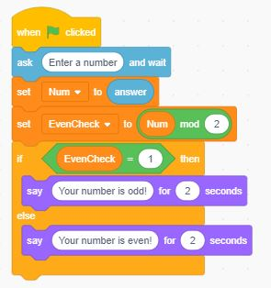

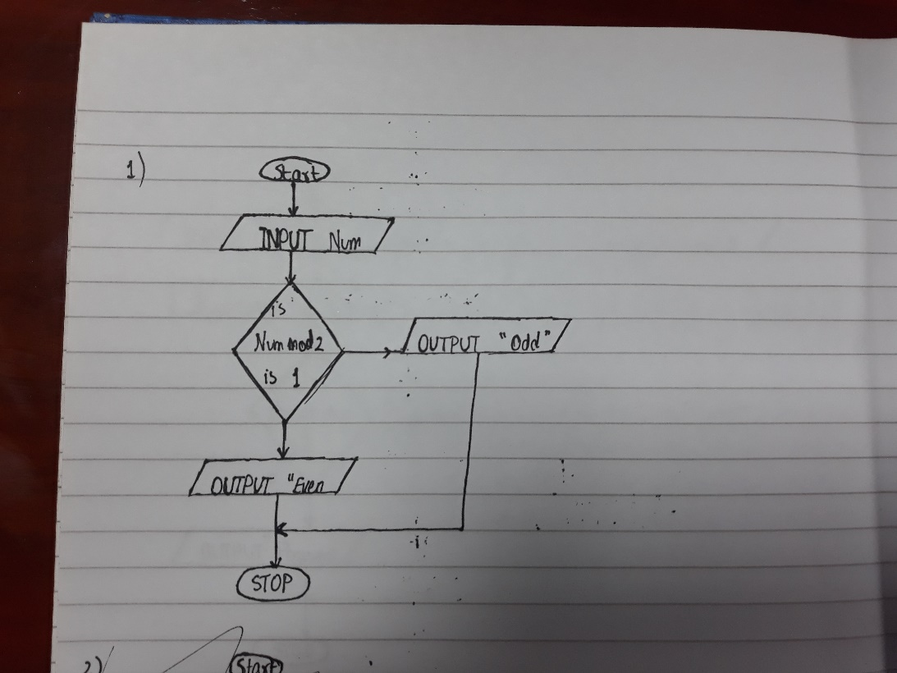

**QUESTION # 2: You are supposed to create a mark sheet. There are total five subjects. Each subject has equal marks i.e., 100, therefore total marks are 500. Take marks of five subjects as an input from the user. Calculate the percentage. If the percentage is below 50, he/she is fail else he/she is pass. Draw a flowchart on your notebook. Convert the flowchart into scratch diagram.**

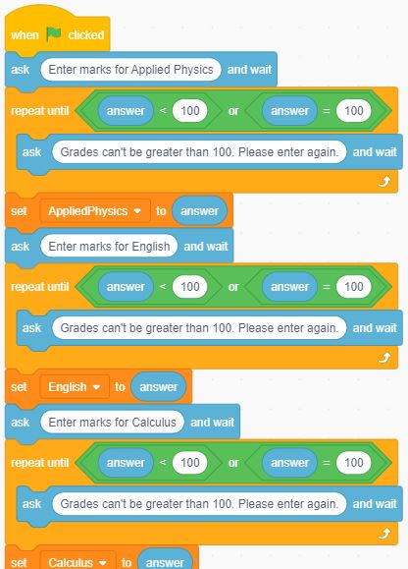

Continue next page

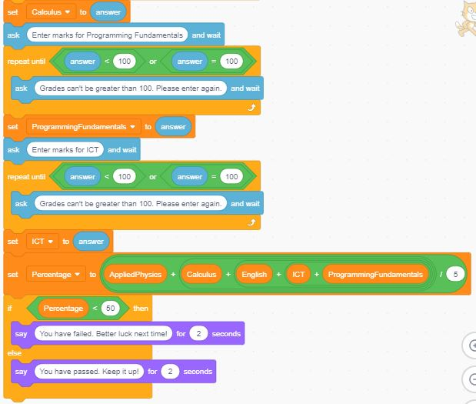

Percentage is divided by 5 instead of 500 since I multiplied it by 100

Flowchart Next Page

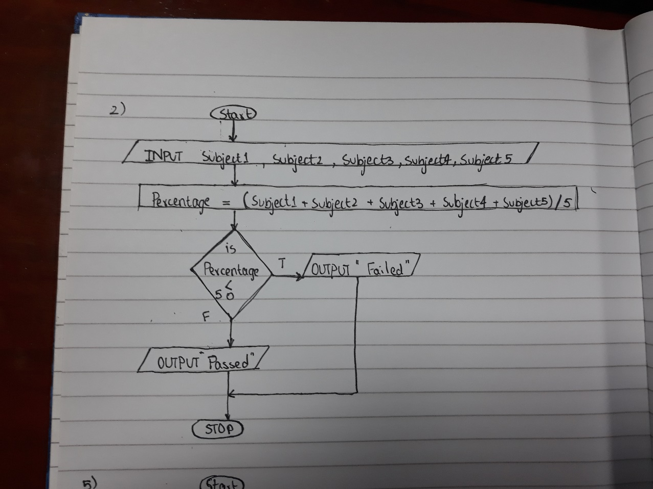

**QUESTION # 3: Draw a hexagon that has six sides. Repeat the hexagon for the same number of times as of its size.**

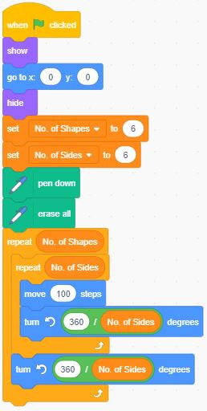

**QUESTION # 4: Given below is a flow chart. Identify the decision and iterative structures in it. Convert the flow chart in to scratch diagram.**

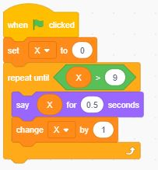

**QUESTION # 5: Given below is a scratch diagram. Write a description of the diagram as well as draw its flowchart on your notebook.**

